

**Software user instruction manual**

**Group Members**

**Names Registration No**

Areesh Zahid (**group leader**) 19508

Muhammad Zeeshan Saleem 18003

Sagar Kumar 42256

Muhammad Bilal Shahid 42496

Zaffar Khan 42277

*Submitted to:* **Dr. Mansoor Ebrahim / Ghazala Shafi**

**GitHub Link:** <https://github.com/Software-Engineering-IU/Store-Management-System/blob/master/Software-User-Instruction-Manual%20(1).docx>

**Project Clothing Store Main Features**

**Login Screen:**

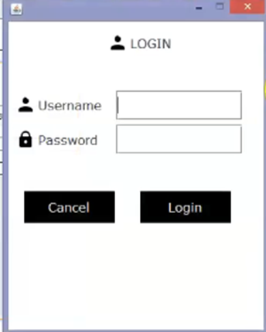The first Page of our project is Login Screen, it have User name: admin and password: admin, once your enter the right username and password the Menu Screen will open.

**Main Menu:**

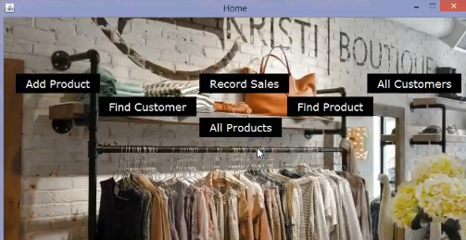The “main menu” option have queries in it, it have option’s to add product, Record Sales, All customers, Find Customers, Find Product, All Products.

**Add Product:**

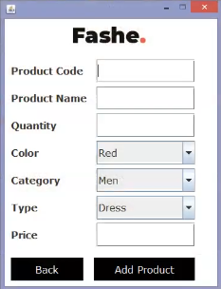Once we buy new products for sale, we use “add product” option to enter that product information to track how many stock we still have. We can set product name, code, size, color, quantity and price.

**All Product:**

The “all product” option store all the product’s information, it tracks the quantities of products and when we reached minimum criteria it notify us so we purchase more quantity of that particular product.

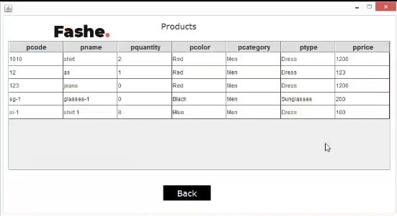

**Record Sales:**

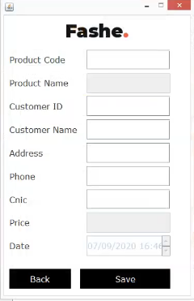The “record sales” option is used when customer buy some product, and it is used to fetch information from “all product” option once customer buy product successfully.

**All Customers:**

The customer information is saved in “All Customers” option, it shows record of what customer buy, date of purchase, and his personal information like name, number, address, cnic.

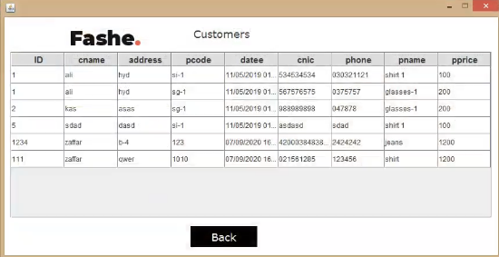

**Database:**

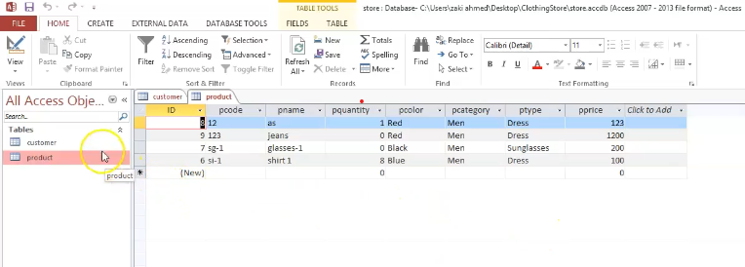The backend (database) of our project is store in MS access, it have two files, one is for product information and second is for customer information.

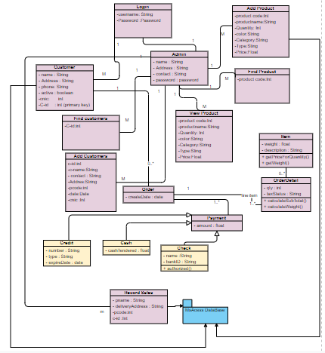**Complete system and program design**